Prospect Mountain High School - Emergency Action Plan

PROSPECT MOUNTAIN HIGH SCHOOL

EMERGENCY CONTACT LIST

EMERGENCY CONTACTS | PHONE NUMBER
Fire/Ambulance | 603-875-0222 or 911
Police Department | 603-875-0757 or 911
Huggins Hospital | 603-569-7500

SCHOOL CAMPUS CONTACTS | PHONE NUMBER
Athletics Director’s Office | 603-875-3800 x3049
Main Office | 603-875-3800
Principal’s Office | 603-875-8800
SAU/Superintendent’s Office | 603-875-7890
School Resource Officer | 603-875-3800 x2002

CONTACT | NAME | OFFICE | CELL
Athletics Director | John Larsen | 603-875-3800 x3049 | 603-361-6212
Principal | Chali Davis | 603-875-8800 | 603-489-8768
Superintendent | Timothy Broadrick | 603-875-9392 | 207-351-7948
School Resource Officer  School Resource Officer | Jamey Balint Kristina Fournier | 603-875-3800 x2002  603-875-3800 x2002 | 603-913-3751  603-438-6000

Introduction

Accidents and injuries are an inherent risk with sports participation and emergencies may arise at any time during athletic events. Proper planning helps ensure that swift action is taken and the best care is provided during a crisis and/or life threatening situation. While some potential emergencies may be averted, it’s the duty of the athletic department to create an emergency action plan to manage these situations appropriately.

Components of the Emergency Plan

These are the basic components of this plan:

- emergency personnel
- roles of first responder
- emergency communication
- emergency equipment
- emergency transportation

Emergency Personnel

With high school athletic practices and competitions, the first responder to an emergency situation is typically the school’s on-site, sport-specific coach. The type and degree of sports medicine coverage for an athletic event may vary, based on factors such as the sport or activity, the location, and the type of practice or event. The first responder in some instances may be a coach or other school personnel. Certification in cardiopulmonary resuscitation (CPR), AED, first aid, and emergency plan review is required for all athletics personnel associated with practices, competitions, skills instruction, and strength and conditioning. Copies of training certificates and/or cards are maintained in the athletics director’s office.

Roles of First Responder

The development of an emergency plan cannot be complete without the formation of an emergency team. The emergency team may consist of a number of healthcare providers including physicians, emergency medical technicians, certified athletic trainers (if applicable), coaches, police and bystanders. Roles of these individuals within the emergency team may vary depending on various factors such as the number of members of the team, the athletic venue itself, or the preference of the sport-specific coach. There are four basic roles within the emergency team. The first and most important role is establishing safety of the scene and immediate care of the athlete. Acute care in an emergency situation should be provided by the most qualified individual on the scene. Individuals with lower credentials should yield to those with more appropriate training. The second role, EMS activation, may be necessary in situations where emergency transportation is not already present at the sporting event. This should be done as soon as the situation is deemed an emergency or a life-threatening event. Time is the most critical factor under emergency conditions. Activating the EMS system may be done by anyone on the team. However, the person chosen for this duty should be someone who is calm under pressure and who communicates well over the telephone. This person should also be familiar with the location and address of the sporting event. The third role, equipment retrieval, may be done by anyone on the emergency team who is familiar with the types and location of the specific equipment needed. Athletic training interns, managers, and coaches are good choices for this role. The fourth role of the emergency team is that of directing EMS to the scene. One member of the team should be responsible for meeting emergency medical personnel as they arrive at the site of the emergency. Depending on ease of access, this person should have keys to any locked gates or doors that may slow the arrival of medical personnel. Police, an athletic training intern, manager, team member, or coach may be appropriate for this role.

Roles within the Emergency Team
1. Establish scene safety and immediate care of the athlete
2. Activation of the Emergency Medical System
3. Emergency equipment retrieval
4. Direction of EMS to scene

Activating the EMS System
Making the Call:
- Notify Police or EMT on site if available or call 911.

Providing Information:
- name, address, telephone number of caller
- nature of emergency, whether medical or non-medical *
- number of athletes
- condition of athlete(s)
- first aid treatment initiated by first responder
- specific directions as needed to locate the emergency scene
- other information as requested by dispatcher

* if non-medical, refer to the specific checklist of the medical emergency action plan

When forming the emergency team, it is important to adapt the team to each situation or sport. It may also be advantageous to have more than one individual assigned to each role. This allows the emergency team to function even though certain members may not always be present.

Emergency Communication

Communication is the key to quick emergency response. Coaches and emergency medical personnel must work together to provide the best emergency response capable and should have contact information established as a part of pre-planning for emergency situations. Communication prior to the event is a good way to establish boundaries and to build rapport between both groups of professionals. If emergency medical transportation is not available on site during a particular sporting event, then direct communication with the emergency medical system at the time of injury or illness is necessary.

Access to a working telephone, whether fixed or mobile, is necessary. A back-up communication plan should be in effect should there be failure of the primary communication system. At any athletic venue, whether home or away, it is important to know the location of a workable telephone. Pre-arranged access to the phone should be established if it is not easily accessible.

Emergency Equipment

All necessary emergency equipment should be at the site and quickly accessible. Personnel should be familiar with the function and operation of each type of emergency equipment. Equipment should be in good operating condition, and personnel must be trained in advance to use it properly. Emergency equipment should be checked on a regular basis and use rehearsed by emergency personnel. The emergency equipment available should be appropriate for the emergency medical providers’ level of training. Creating an equipment inspection log book for continued inspection is strongly suggested. It is recommended that a few members of the emergency team be trained and responsible for the care of the equipment.

It is important to know the proper way to care for and store the equipment as well. Equipment should be stored in a clean and environmentally controlled area. It should be readily available when emergency situations arise.

Medical Emergency Transportation

Emphasis is placed at having an ambulance on site at high risk sporting events. EMS response time is additionally factored in when determining on site ambulance coverage. Ambulances may be coordinated on site for other special events/sports, such as tournaments or championship events. Consideration is given to the capabilities of transportation service available (i.e., Basic Life Support or Advanced Life Support) and the equipment and level of trained personnel on board the ambulance. In the event that an ambulance is on site, there should be a designated location with rapid access to the site and a cleared route for entering/exiting the venue. In the event of an emergency, the 911 system will still be utilized for activating emergency transport.

In an emergency situation, the athlete should be transported by ambulance, where the necessary staff and equipment is available to deliver appropriate care. Emergency care providers should refrain from transporting unstable athletes in inappropriate vehicles. Care must be taken to ensure that the activity areas remain supervised should the emergency care provider leave the site to transport the athlete. Any emergency situations where there is impairment in level of consciousness (LOC), airway, breathing, or circulation (ABC) or there is neurovascular compromise should be considered a “load and go” situation and emphasis placed on rapid evaluation, treatment and transportation. In order to provide the quickest possible care for Prospect Mountain High School athletes, transportation will be provided to Huggins Hospital.

Emergency Plan - Summary

Emergency Personnel:
- Sport-specific coach or assistant coach
- Athletics Director
- Event Manager in lieu of Athletics Director

Roles of First Responder:
- Survey the scene and immediate care of the injured or ill student-athlete
- Activation of emergency medical system (EMS)
  - Sport-specific coach delegates tasks once a medical necessity is recognized
- Designate individual to retrieve emergency equipment
- Direction of EMS to scene
  - open appropriate gates
  - designate individual to “flag down” EMS and direct to scene
  - scene control: limit scene to first aid providers and move bystanders away from area

Emergency Communication:
- 2-way radio communication (when multiple events are being covered)
- Cellular telephone
- Fixed telephones
  - Athletics Director’s office
  - Main office (front of school)

Emergency Equipment:
- Team medical kits, including emergency procedures cards
- AED
- Vacuum splint bags

- See included campus map for AED locations – one stationary device on the first floor outside the Receptionist’s window near the main entrance (front of school), and two portable devices on the first floor in the coach’s closet located in the rear of the gym (double maroon doors on left).

Special Notes

Once the injured athlete is in the hands of the physician or ambulance personnel, the sport-specific coach or assistant coach in charge will ensure that the following duties are completed:

- Check about the necessity of calling the athlete’s parent(s)/guardian(s).
- Make arrangements to get the injured athlete’s personal belongings to the hospital (if necessary).
- Arrange for return transportation to parent(s)/guardian(s).
- If the injury occurred during a non-traditional practice period and no member of the Prospect Mountain Athletic Training Staff is on-campus, contact EMS if there is a concern for an athlete. Afterwards notify a member of the Athletic Training Staff and the Athletics Director, informing them about the injury and status of the athlete, as soon as possible.
- Complete an Injury/Accident Report and give it to the Athletics Director within 24 hours.

* These procedures should be followed for injuries occurring on away trips.

Non-EMS Injuries Requiring Medical Attention

Injuries that will require medical attention, but not serious enough for EMS transportation, will be referred to the proper physician or medical facility by the sport-specific coach or assistant coach. There are many things to consider when attending to these injuries; therefore, they will be administered on a case-by-case basis according to the needs of the individual athlete.

Examples: Head injury (concussion)
Lacerations (which may require suturing)
Possible fractures
Orthopedic injuries that should have early medical assessment (sprains and strains)

Refer the athlete to the Athletics Director or Events Manager immediately (i.e. radio, direct transport to the school building). The sport-specific coach will make needed referrals. If the injury occurs during a non-traditional practice period, or away contest, and no on=site medical staff is available, refer the athlete directly to the nearest medical facility and ask for advice/assistance.

Conclusion

The importance of being properly prepared when athletic emergencies arise cannot be stressed enough. An athlete’s survival may hinge on how well trained and prepared athletic healthcare providers are. It is prudent to invest athletic department “ownership" in the emergency plan by involving the athletic administration and sport coaches as well as sports medicine personnel. The emergency plan should be reviewed annually with all athletic personnel, along with bi-annual CPR, AED, and first aid refresher training. Through development and implementation of the emergency plan, the athletic department helps ensure that student athletes will have the best care provided when an emergency situation does arise.

Approved by _________________________________________ __________________
Athletics Director Date

Approved by _________________________________________ __________________
Superintendent Date

MEDICAL EMERGENCY ACTION PLAN

IN THE EVENT OF AN EMERGENCY:

ATHLETIC TRAINER NOT ON SITE
Emergency Situation

Alert EMS (Emergency Medical Service)

Call or send someone to call 911 or local EMS by:
(do not leave injured person unattended)

Cellular Phone/Main Office Phone/School Phone

The person who is calling 911 must stay on the phone and state:

1. His/her name
2. School and sport
3. Location (specific field/gym)
4. Type of emergency

*The person who made the call must wait for the ambulance to arrive and send someone to meet the ambulance to direct them to the injured person. As soon as it is safe to do so, inform the Athletic Director and/or Principal of the emergency.

Appendix A - Venue Directions/Campus Map

Softball Field: 242 Suncook Valley Rd, Alton, NH 03809
¼ mile from entrance on the right. Early spring *

Soccer Field, Cross Country, Outdoor Track, Unified Outdoor Track: 242 Suncook Valley Rd, Alton, NH 03809
½ mile from entrance on the right. Emergency access (D): Travel ¾ mile from entrance to stop sign. Turn right, travel past the dumpsters, follow the fire lane path around the back of the school until you reach the track.

Gymnasium (Volleyball, Basketball, Winter Spirit, Unified Basketball): 242 Suncook Valley Rd, Alton, NH 03809
¾ mile from entrance on the right. Enter through school main entrance, walk through the cafeteria, take a left into the gymnasium.

Indoor Track: 242 Suncook Valley Rd, Alton, NH 03809
¾ mile from entrance on the right. Athletes meet under the portico at school main entrance.

Tennis Courts: 242 Suncook Valley Rd, Alton, NH 03809
¾ mile to stop sign. Turn left for tennis courts, continue to parking lot.

Baseball Field: 242 Suncook Valley Rd, Alton, NH 03809
¾ mile to stop sign. Turn left, continue to parking lot. Baseball field is over the hill, past the unified soccer field. Early spring *

Soccer Practice Field: 242 Suncook Valley Rd, Alton, NH 03809
¾ mile to stop sign. Turn left, continue to parking lot. Soccer practice field is behind the tennis courts.

Unified Soccer Field: 242 Suncook Valley Rd, Alton, NH 03809
¾ mile to stop sign. Turn left, continue to parking lot. Unified soccer field is over the hill.

Golf - Farmington Country Club: 181 Main St, Farmington, NH 03835
Farmington Country Club (FCC) is approximately 15 minutes from PMHS. Via NH-28 North to the traffic circle, take the 1st exit onto NH-11 E. Travel approximately 8 miles, turn left onto Central St. Travel approximately .9 miles, turn right onto Main St. Travel approximately 1 mile, FCC will be on the left.

Bass Fishing - Fire Station Pond: 65 Frank C Gilman Hwy, Alton, NH 03809
The Fire Station Pond is approximately 5 minutes from PMHS, and across the street from the Town of Alton Fire Station. Via NH-28 North, continue to traffic circle. Travel through traffic circle to 4th exit and continue on NH-11. Travel approximately 1 ½ miles, take a left onto NH-140. The Fire Station Pond is approximately ½ mile on the right (across from the Town of Alton Fire Station).

Alpine Ski - Gunstock Mountain Resort: 719 Cherry Valley Rd, Gilford, NH 03249
Gunstock Mountain Resort is approximately 25 minutes from PMHS. Via NH-28 North, at the traffic circle, take the 4th exit onto NH-11/NH-28A. Travel 8 miles, turn left onto NH-11A W. Travel 4 miles, turn left onto Panorama Dr. Gunstock lodge is 1-mile in.

*Alton Central School Softball/Baseball Fields (Softball / Baseball early spring): 41 School St, Alton, NH 03809.
Alton Central School (ACS) is approximately 6 minutes from PMHS. Via NH-28 North, at the traffic circle, take the 4th exit onto NH-11/NH-28A. Travel approximately .6 miles, take a left onto School Street. At the stop sign, take a left onto Pine Street, take a left onto Appleyard Lane. Softball / Baseball fields are on the left.
EMERGENCY ACTION MAP
Prospect Mountain High School – 242 Suncook Valley Road, Alton NH 03809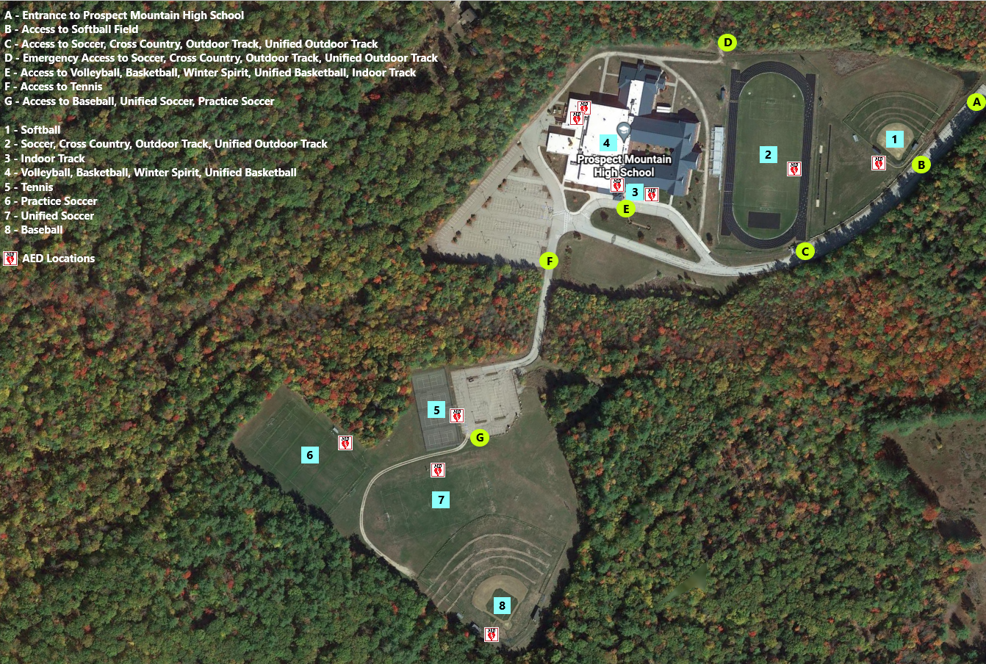

A – Entrance to Prospect Mountain High School
B – Access to Softball Field
C – Access to Soccer Field, Cross Country, Outdoor Track, Unified Outdoor Track
D – Emergency Access to Soccer, Cross Country, Outdoor Track, Unified Outdoor Track
E – Access to Volleyball, Basketball, Winter Spirit, Unified Basketball, Indoor Track
F – Access to Tennis
G – Access to Baseball, Unified Soccer, Practice Soccer

1 – Softball
2 – Soccer, Cross Country, Outdoor Track, Unified Outdoor Track
3 – Indoor Track
4 – Volleyball, Basketball, Winter Spirit, Unified Basketball
5 – Tennis
6 – Practice Soccer
7 – Unified Soccer
8 – Baseball
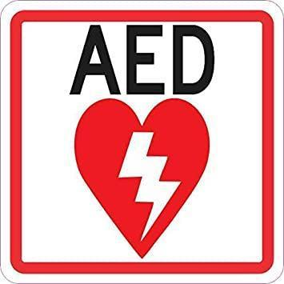 AED Locations
Appendix B - Response Protocol Worksheet 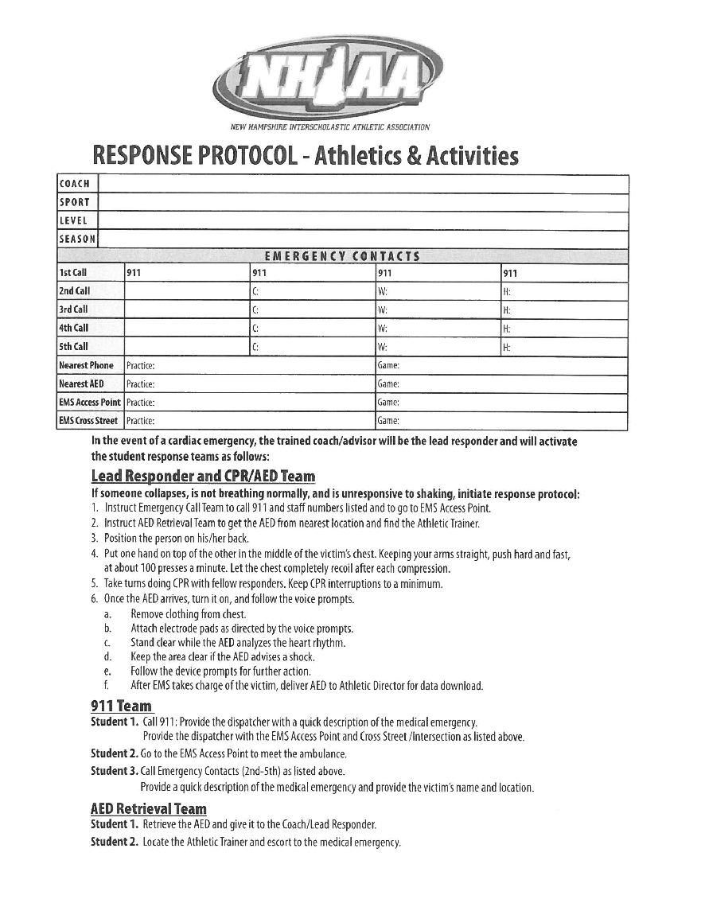
Appendix C - Response Team Worksheet
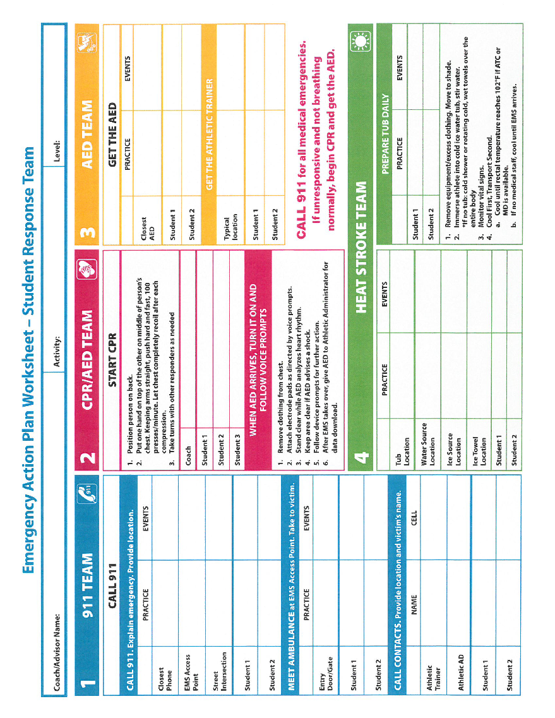
Appendix D - Heat Illness Signs and Safety Tips
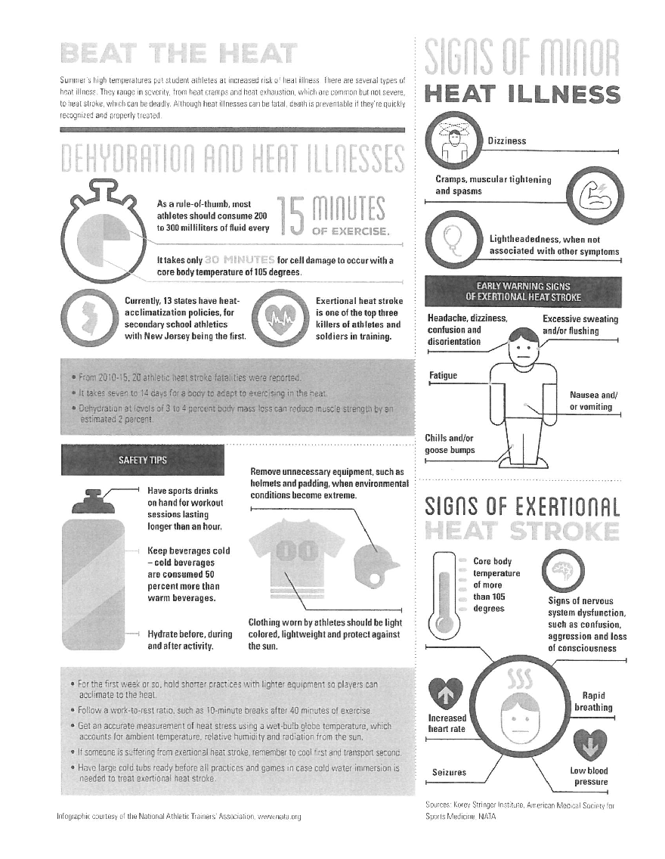
Appendix E - Heat Stroke Prevention and Survival Steps
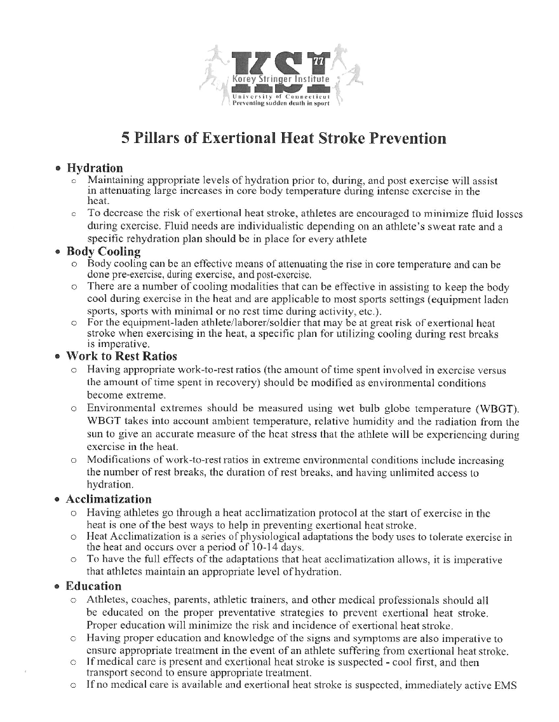
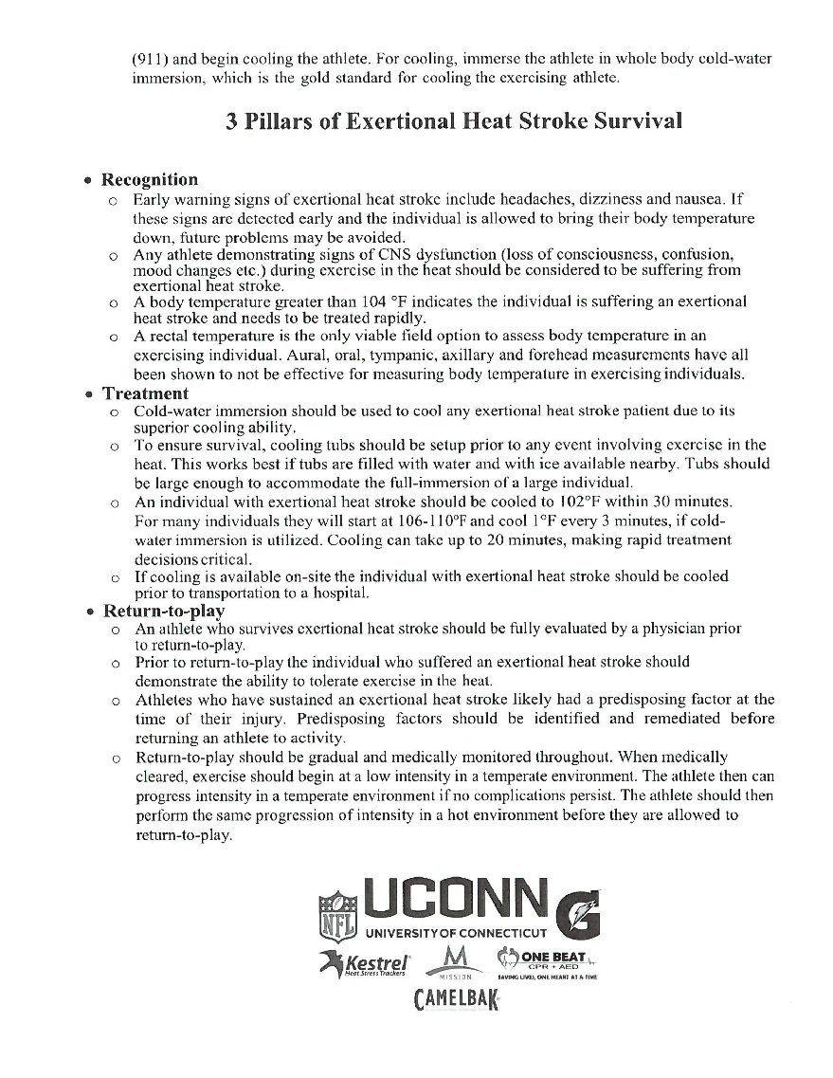
Appendix F - SAU 301 Emergency Action Plans
